The Government PU College, Rajanakunte

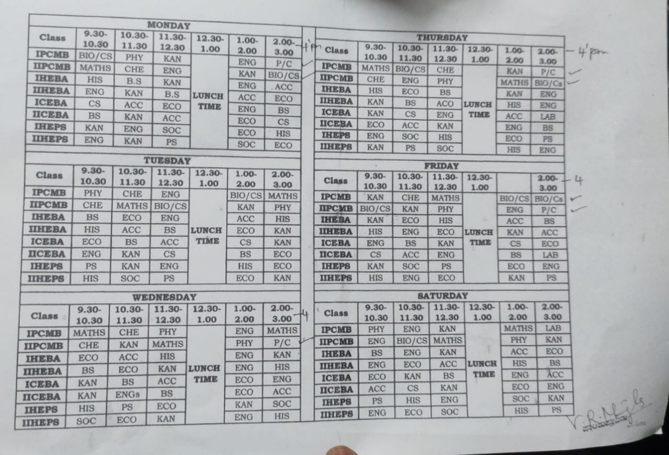

The Government High School, Rajanakunte

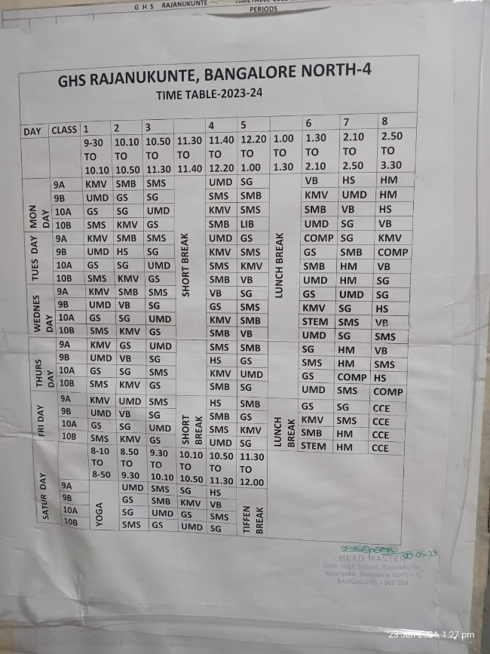

The Government Primary School, Rajanakunte

